Future changes to Band Circuit:

* Move Via away from surface mount

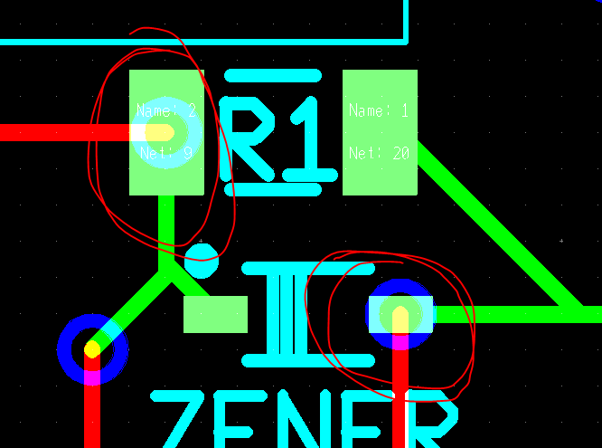

* Get correct 6- prong thing for attaching a J-Tag

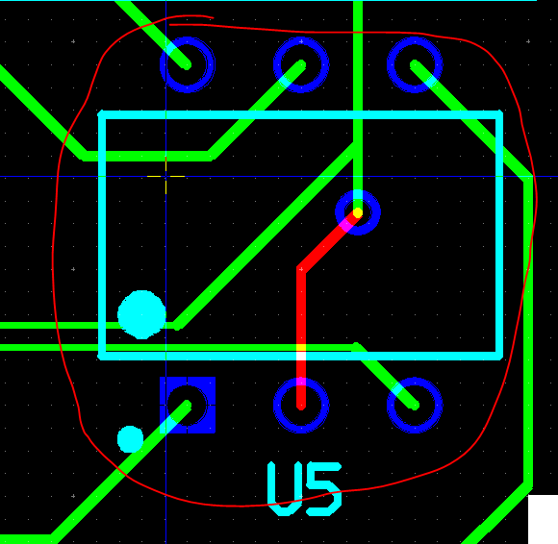

* Extend these pads out just a little to assist in soldering.

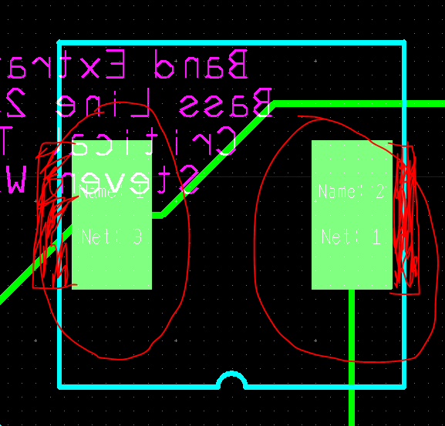

* Make Sure this resistor is going to be smt or through hole, they are different in multisim and Ulti board. multisim has it as an smt, ultiboard has it as through hole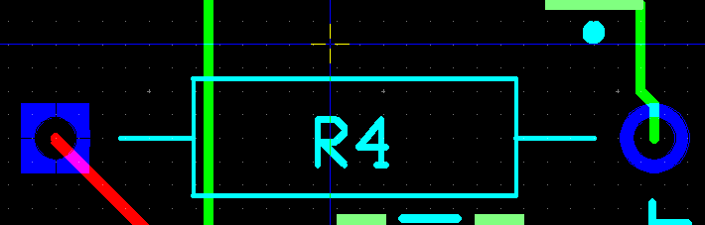
* Get correct sized 100k Potentiometer.

